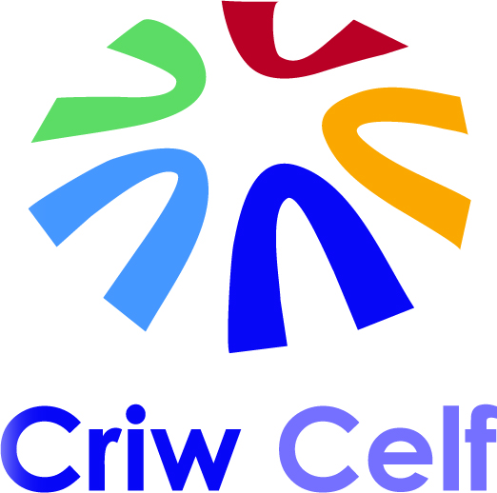
Cyfarfod Blynyddol Partneriaid Cenedlaethol
Annual National Partners Meeting
10am-4pm ~ 28/06/2017

Oriel Ynys Môn, Rhosmeirch, Llangefni, Ynys Môn / Anglesey LL77 7TQ
10 - 10:15am | Cofrestru a choffi. | Registration & coffee.
10:15 - 10:30am | Croeso a chyflwyniadau: Ceri Williams, Oriel Ynys Môn a Gwawr Wyn Roberts, Cyngor Gwynedd. | Welcome & introductions - Ceri Williams, Oriel Ynys Môn & Gwawr Wyn Roberts, Gwynedd Council.
10:30 - 11:00am | Criw Celf Gogledd Cymru: Gweithio’n Rhanbarthol - Siân Fitzgerald - Cyngor Sir Ddinbych, Julie Wem - Canolfan Grefftau Rhuthun a Lisa Taylor - Galeri Caernarfon. | Criw Celf North Wales: Working Regionally - Siân Fitzgerald - Denbighshire County Council, Julie Wem - Rhuthin Craft Centre & Lisa Taylor - Galeri Caernarfon.
11:00 - 11:30am | Cyflwyno Astudiaeth Achos - Preswyliad celf Criw Celf yng Nghastell Bodelwyddan gyda’r artist Lisa Carter. | Case Study Presentation - Criw Celf’s art residency at Bodelwyddan Castle with artist Lisa Carter.
11:30 - 12:15pm | Diweddariad gan Gyngor Celfyddydau Cymru, Louise Wright. | Arts Council of Wales Update, Louise Wright.
12:15 - 1:00pm | Trafodaeth a Rhannu Gwybodaeth - Pawb | Discussion and Information Sharing - All
1:00 - 1:45pm | Cinio, cyfle i ymweld â’r arddangosfeydd a rhwydweithio. | Lunch, opportunity to visit the exhibitions and networking.
1:45 - 2:00pm | Codi’r Bar, cyfranogwyr Canolfan Grefftau Rhuthun yn rhannu eu profiadau. | Raising the Bar, Rhuthin Craft Centre participants share their experiences.
2:00 - 2:30pm | Kyffin100, Ceri Williams, Oriel Ynys Môn. | Kyffin100, Ceri Williams - Oriel Ynys Môn.
2:30 - 2:45pm | Paned. | Tea break.
2:45 - 3:45pm | Gweithio gyda casgliadau orielau ac amgueddfeydd, gweithdy celf ymarferol gyda’r arlunydd Dr Maria Hayes. | Working with museum & gallery collections, practical art workshop with artist Dr Maria Hayes.
3:45 - 4pm | UFA, crynhoi a chloi. | AOB, round-up and close.

Teithio i Ynys Môn – manylion ar gael yma… http://www.croesomon.co.uk/cy/eich-ymweliad/
Llety – manylion ar gael yma… http://www.croesomon.co.uk/cy/ble-i-aros/

Travelling to Anglesey – info. available here… http://www.visitanglesey.co.uk/en/plan-your-visit-new/ / Accommodation – info. available here… http://www.visitanglesey.co.uk/en/where-to-stay/

